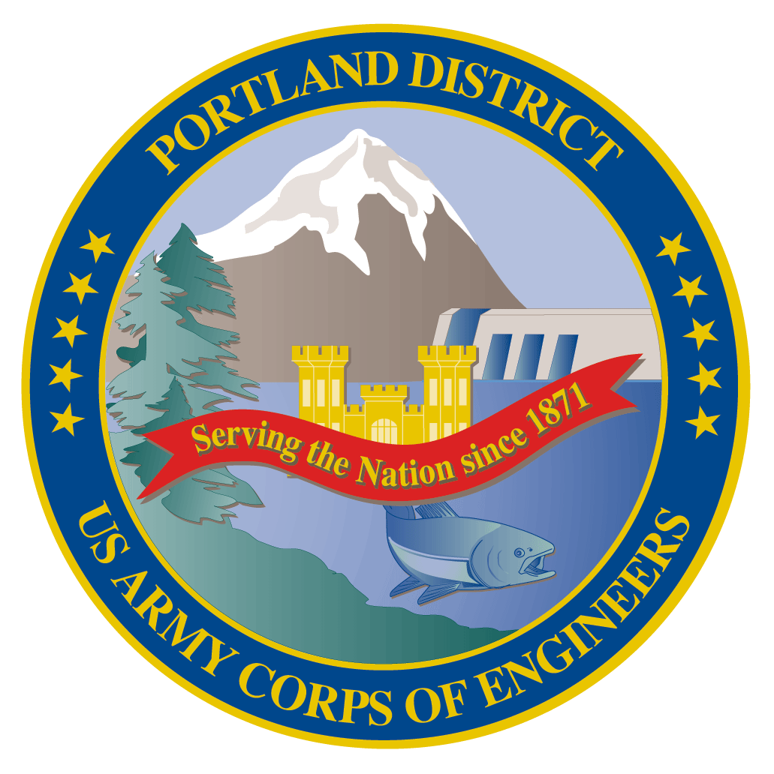
Lower Columbia River Fish Facility Design Review Work Group (FFDRWG)

USACE, Portland District

August 2021 Meeting Agenda
August 5, 2021 09:00-11:00
Join Meeting: https://usace1.webex.com/usace1/j.php?MTID=m5c365c1bf762dad74cbaa2985e8e04fb
Meeting password: FFDRwG2021!
(*if using your phone for audio, log in through Webex and have the meeting call you)

Join by phone (audio only, no Webex): (844) 800-2712 | Access Code: 199 571 1422

Introductions
FFDRWG members:
BPA
*Scott Bettin
Kim Johnson
Siena Lopez-Johnston
*Christine Petersen
Greg Smith
Leah Sullivan
Ben Hausmann
NOAA
Blane Bellerud
Gabriel Brooks
*Trevor Conder
*Kinsey Frick
Claire McGrath
Josie Thompson
Logan Negherbon
USFWS
*Dave Swank
States
Erick Van Dyke (ODFW)
*Charles Morrill (WDFW)
CRITFC/Tribes
*Tom Lorz (CRITFC)
Blaine Parker (CRITFC)
Tom Skiles (CRITFC)
Laurie Porter (CRITFC)
*Greg Silver (CRITFC)
Casey Baldwin (CTCR)
Michael Karnosh (CTGR)
Lawrence Schwabe (CTGR)
Torey Wakeland (CTGR)
Aaron Jackson (CTUIR)
Ralph Lampman (YN)
NPCC
Leslie Bach
Kris Homel
FPC
*Erin Cooper
PSMFC
Alan Brower
Darren Chase
Roger Clark
Mark Leonard
Scott Livingston
Nicole Tancreto
Don Warf
CENWD
*Doug Baus
Tim Dykstra
Dan Feil
Mike Langeslay
Cindy Studebaker
*Lisa Wright
CENWW
Karl Anderson
Chris Peery
Marvin Shutters
Denise Griffith
CENWP-OD
*Andrew Derugin
Rebecca Cates
Jeanette Wendler
Bob Cordie
*Jeffrey Randall
*Scott Fielding
*Eric Grosvenor
*Michael Lotspeich
Laura Rickets
Tammy Mackey
Darren Gallion
*Nathan McClain
Robert Wertheimer
Karrie Gibbons
CENWP-PM
Jim Adams
*Eric Bluhm
Ian Chane
Jeff Hicks
Steve Sipe
Bob Winters
*Brad Eppard
David Griffith
Fenton Khan
Rachel Laird
*Jake Macdonald
Rich Piaskowski
Jon Rerecich
Ida Royer
David Trachtenbarg
Jeremiah Woodard
Erin Kovalchuk
CENWP-ENC
*Adam White
Brandt Bannister
Bridget Bell
Jonathon Brink-Roby
*Shari Dunlop
Laurie Ebner
Curtis Lipski
*Chris Motti
*Steve Schlenker
Max Wilson-Fey
Mehdi Roshani

Action items from last meeting
- Max Wilson-Fey (ENC) will ask Laurie Ebner about the effects of deflectors and report back to FFDRWG
- Jacob Macdonald (NWP) will invite Laurie Ebner to next FFDRWG, reschedule for a time before Laurie retires for good
  - FFDRWG field trip to Bonneville Dam spillway on 29-June accomplished both!

Topics for FFDRWG Discussion/Review/Coordination
- JDA adult lamprey passage improvements – Eric Bluhm (PM), Adam White (TL), Jacob Macdonald (FC)
  - Brief FFDRWG on results of 7/29 site visit with NOAA to review water supply options (White/Schlenker)
- TDA adult lamprey passage improvements – Eric Bluhm (PM), Adam White (TL), Jacob Macdonald (FC)
  - LPS design guidelines:
    - Hattie Zobott, Christopher C. Caudill, Matthew L. Keefer, Ralph Budwig, Kinsey Frick, Mary Moser, and Steve Corbett. 2015. Design Guidelines for Pacific Lamprey Passage Structures. Study Code LMP-P-13-1.
    - Pacific Lamprey Technical Workgroup. 2017. Practical guidelines for incorporating adult Pacific lamprey passage at fishways. June 2017. White Paper. 47 pp + Appendix. Available online: https://www.fws.gov/pacificlamprey/mainpage.cfm
    - Any other guideline/criteria we should consider?
- BON1 adult lamprey passage improvements – Bob Winters (PM), Adam White (TL), Jacob Macdonald (FC)
  - Brief FFDRWG on results of 7/26 PDT site visit to Bradford Island entrance
    - Location for collection box (White)
    - Potential gravity-fed water source (White/Derugin)

Written project updates
- JDA turbine rehab – Steve Sipe (PM), Curtis Lipski (TL), Jon Rerecich (FC)
- TDA AWS Debris Management– Erin Kovalchuk (PM), Mehdi Roshani (TL), Jon Rerecich (FC)
- BON Second Powerhouse FGE – Jim Adams (PM), Bridget Bell (TL), Jon Rerecich (FC)
- JDA adult lamprey passage improvements – Eric Bluhm (PM), Adam White (TL), Jacob Macdonald (FC)
- TDA adult lamprey passage improvements – Eric Bluhm (PM), Adam White (TL), Jacob Macdonald (FC)
- BON1 adult lamprey passage improvements – Bob Winters (PM), Adam White (TL), Andrew Derugin (FC)
- BON2 adult lamprey passage improvements – Bob Winters (PM), Andrew Derugin (TL), Andrew Derugin (FC)

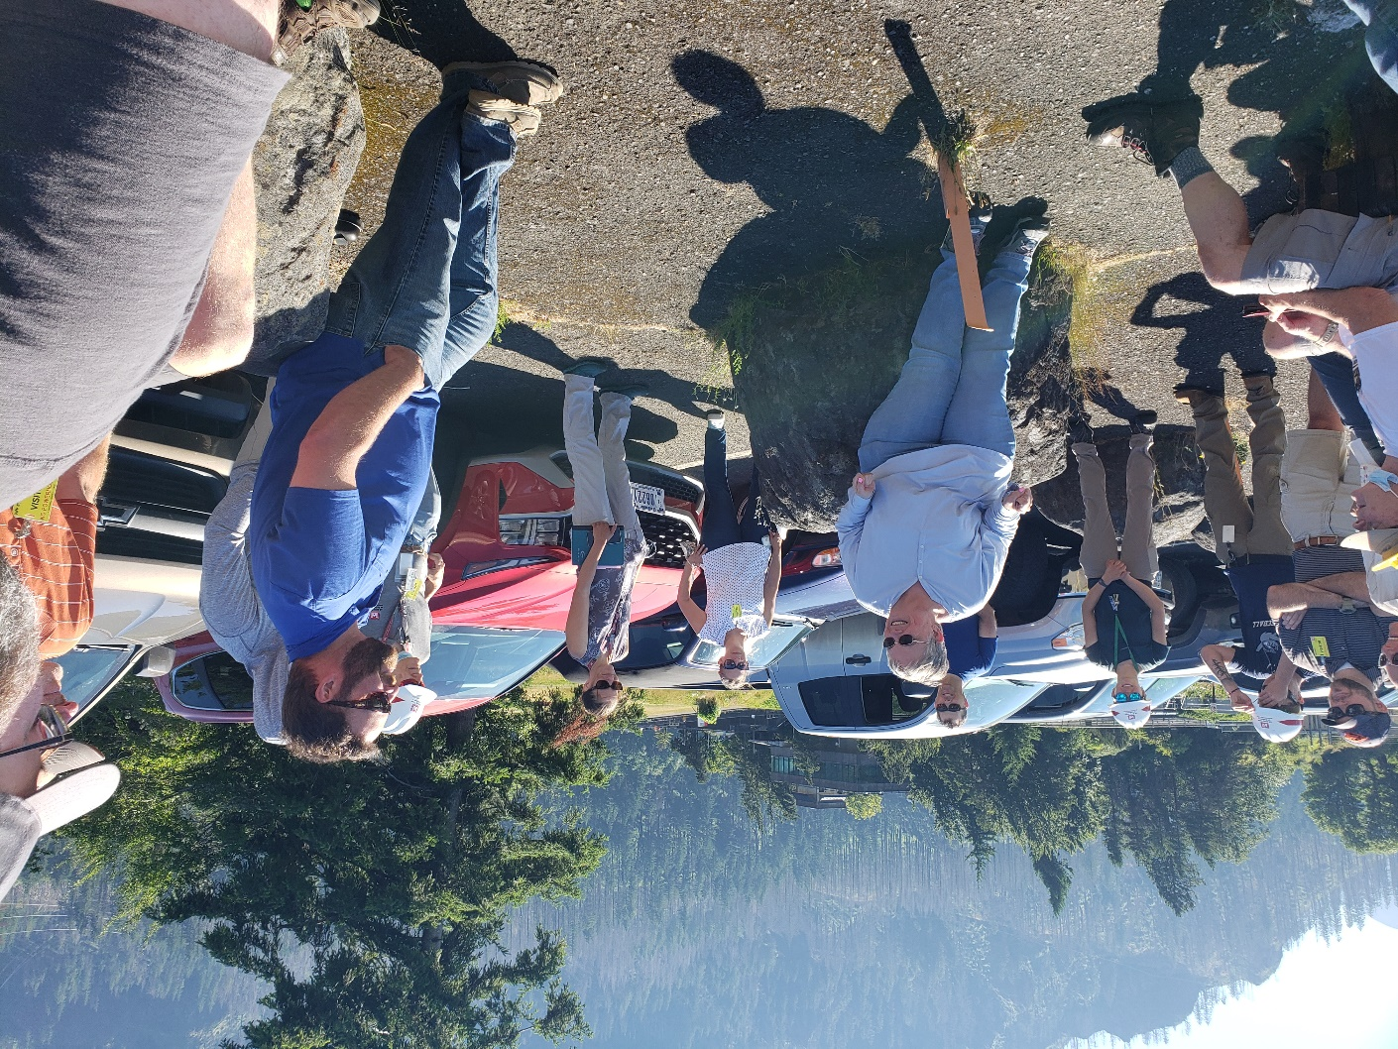

Fish Facility Design Review Work Group (FFDRWG)

USACE, Portland District

Project Update
Date Prepared/Updated: 2021-04-01

JDA Turbine Rehab
Project Identifier: | P2 #
Project Manager (PM): | Steve Sipe (CENWP-PMF-P)  Steven.C.Sipe@usace.army.mil
Technical Lead (TL): | Curtis Lipski (CENWP-ENC-HD)  Curtis.L.Lipski@usace.army.mil
FFDRWG Coordination (FL): | Jon Rerecich (CENWP-PME)  Jonathan.G.Rerecich@usace.army.mil

Project Description
The purpose of this project is to address reliability concerns and maximize production of hydroelectric power at JDA, which includes electrical energy production and electrical grid ancillary services while at the same time, improving survival of fish passing through the turbines. Maximum production of hydroelectric power at JDA will be realized through increased reliability and increased efficiency. Reliability improvements will be realized through a combination of replacement and refurbishment of powertrain equipment to include, but not limited to, turbine runners, shafting, generators, isophase bus, breakers, switches, and transformers. Efficiency improvements will be realized through increased turbine efficiencies associated with new turbine runners and other modifications to the turbines.
The purpose of this project is also to increase survival of turbine passed fish. Increased survival of turbine passed fish will be realized through developing state-of-art hydroelectric turbines to obtain improved fish passage survival through the turbines. The design of the state-of-the-art turbines will be an iterative and collaborative process that focuses on fish-friendly design features and criteria. This iterative and collaborative design process will be similar to the ongoing Ice Harbor L&D turbine runner replacement design and upcoming McNary L&D turbine runner replacement in NWW. Phase 1A recommendations include replacing up to 14 units with combination fixed blade & adjustable blade to obtain improved fish passage survival through the turbines.

Project Schedule
Phase 1 Short Term Schedule | Start | Finish
30% DDR/P&S review | 3/12/2020 | 4/1/2020
60% DDR/P&S review | 8/28/2020 | 9/18/2020
90% DDR/P&S review | 9/21/2021 | 2/18/2022
BCOES review | 1/24/2022 | 11/11/2022

Overall Schedule Milestones | Date
Contract award | October 2024
Collaborative design process Model testing | 2024-2029
First unit installation | 2031-2033
Unit installation complete | 2040-2045

Current Status
- Final VE study report due Feb. 19, 2021

- The 1:25 scale physical observational turbine model rehab and relocation is complete. The model will be used to inform the development of the Phase 1 Plans and Specifications package, to document the hydraulic conditions that affect the biological performance of the existing JDA turbines, and to support the collaborative and iterative design process in Phase 2. ERDC baseline model validation testing with the existing runner has been scheduled for last week and this week. Baseline model data collection for Test Series 1 will be occurring until May 2021 at which time ERDC is scheduled to transition back to McNary. This task includes preparation of a data report documenting the runs performed, results, conclusions, and recommendations. Runner evaluation tests will need to carry over to Test Series 2 (not yet scoped), which is expected to occur in late 2021 or early 2022.

- Tailrace flow patterns have been validated in the 1:45 JDA general model and in a CFD model. Model runs will commence after further HAC modeling is complete and preliminary options for the turbine mix are established. The focus of the tailrace modeling will be to assess juvenile egress and conditions for adult approach to the fish ladder entrances.

Topics for FFDRWG Review/Coordination
None currently.

Fish Facility Design Review Work Group (FFDRWG)

USACE, Portland District

Project Update
Date Prepared/Updated: 2021-06-03

TDA Backup AWS Debris Management EDR
Project Identifier: | P2 #
Project Manager (PM): | Erin Kovalchuk (CENWP-PMF)  Erin.H.Kkovalchuk@usace.army.mil
Technical Lead (TL): | Mehdi Roshani (CENWP-ENC)  Mehdi.Roshani@usace.army.mil
FFDRWG Coordination (FC): | Jon Rerecich (CENWP-PME)  Jonathan.G.Rerecich@usace.army.mil

Project Description
This project is to evaluate alternatives to remove debris from The Dalles Dam Auxiliary Water Supply (AWS) trash rack. Debris build-up on the rack currently causes high head differential across the rack. Fish Unit Rehab, potentially starting in the year 2024, requires the AWS backup system to operate during the rehab to provide adequate flow for fish attraction. Fish Unit Rehab duration is one year per unit for a total of two years. Long term use of the backup AWS system will be part of the alternatives evaluation.

Project Schedule

Milestone | Start | End
Criteria and Constraint Report | 4/19/2021 | 8/6/2021
Value Management | 8/9/2021 | 8/20/2021
Alternative Evaluation Report | 8/23/2021 | 12/10/2021
Draft Final Report | 12/13/2021 | 4/1/2022
ATR | 3/21/2022 | 4/1/2022
Final Report | 4/4/2022 | 5/27/2022
Closeout | 5/30/2022 | 6/3/2022

Current Status
Working on the Criteria and Constraints for the EDR.

Topics for FFDRWG Review/Coordination
None currently. PDT will solicit FFDRWG participation during the Engineering Design Report (EDR) process.

Fish Facility Design Review Work Group (FFDRWG)

USACE, Portland District

Project Update
Date Prepared/Updated: 2021-03-30

BON Second Powerhouse FGE
Project Identifier: | P2 #
Project Manager (PM): | Jim Adams (CENWP-PMF)  James.R.Adams@usace.army.mil
Technical Lead (TL): | Bridget Bell (CENWP-ENC)  Bridget.M.Bell@usace.army.mil
FFDRWG Coordination (FL): | Jon Rerecich (CENWP-PME)  Jonathan.G.Rerecich@usace.army.mil

Project Description
Steel plates were installed in all units in the A and B gatewells to restrict flow. During routine inspections, however, it became apparent that the anchoring system for the steel plates was inadequate. In effect, the nuts and anchoring bolts holding down the plates had come lose, posing the risk that the plates could detach and potentially take out a unit. All flow restriction plates were removed from the units.
A concrete corbel will be installed in the same location as the flow control plates with the design goal to achieve similar gatewell hydraulic conditions as the flow control plates. This new concrete corbel has been designed to meet the flow criteria established and tested for the previous flow restrictor plates to meet the hydraulic and biological goals.

Project Schedule
Awarded 21 December 2020 to Northbank Civil and Marine. Notice to proceed 29 December 2020.
CLIN | Status | Description | Award/Exercise Date | Construction Execution Window
1 | Mandatory | Mobilization/Demobilization | December 2020 Award
2 | Mandatory | Unit 15 Construction | December 2020 Award | February 2021-April 2021
3 | Optional | Second Mob/Demob and Unit 11 Construction | Sept. 30, 2021 | Dec 2021-Feb 2022
4 | Optional | 2 Additional Units | Sept. 30, 2021 | Extend through May 2022
5 | Optional | 2 Additional Units | Nov. 30, 2021 | Extend through August 2022
6 | Optional | 2 Additional Units (Unit 18 + 1 more Unit) | Nov. 30, 2021 | Extend through February 2023

Current Status
- Construction in unit 15 is underway and on track. Unit 15 is on the outage schedule March 1-April 20. The contract states the unit must be completed by April 15th.
- Hydraulic Testing Spring 2021 – During March contract negotiations with NWP, the A/E contractor expressed concerns in meeting the testing deadline and deliverables due to procurement of equipment, preparation/calibration of equipment, and staffing limitations. Hydraulic testing will not occur this year.
- Hydraulic tests will be needed next spring to meet the upper 1% test range of 18.0-18.5 kcfs.
- Impacts to the B2FGE concrete work contract are being evaluated. The concrete work will be delayed by one year.
- Rerecich owes Lorz a beer.

Topics for FFDRWG Review/Coordination
None currently.

Fish Facility Design Review Work Group (FFDRWG)

USACE, Portland District

Project Update
Date Prepared/Updated: 2021-08-03

JDA adult lamprey passage improvements
Project Identifier: | P2 # 492402
Project Manager (PM): | Eric Bluhm (CENWP-PM-FP)  Eric.V.Bluhm@usace.army.mil
Technical Lead (TL): | Adam White (CENWP-ENC)  Adam.J.White@usace.army.mil
FFDRWG Coordination (FC): | Jacob Macdonald (CENWP-PME)  Jacob.Macdonald@usace.army.mil

Project Description
- Modify NFL LPS to increase the capacity and reliability of the system
This is a fish safety/health issue, and the upgrade needs to happen. Current water supply is insufficient so tank cannot be installed without upgraded water supply.
- gravity-fed water supply or alternative, more reliable pump configuration.
- larger collection box
- South fish ladder entrance improvements (rounded crest, slot cover/filler)
Caps cannot be added to South Ladder entrance weir due to FPP submergence criteria, so the weir needs to be modified more extensively to provide rounded weir crests and guide slot covers.

Project Schedule
Design: FY 2021 – FY 2022
30% DDR – July 2021
60% DDR – October 2021
90% DDR – April 2022
BCOES – May 2022
Construction: December 2022 - March 2023
Evaluation/Closeout: FY 2023

Current Status
30% DDR review comments being evaluated. Site visit with NOAA on 7/29 to review water supply options.

Topics for FFDRWG Review/Coordination
Brief FFDRWG on results of 7/29 site visit with NOAA to review water supply options.

Fish Facility Design Review Work Group (FFDRWG)

USACE, Portland District

Project Update
Date Prepared/Updated: 2021-08-03

TDA adult lamprey passage improvements
Project Identifier: | P2 # 492403
Project Manager (PM): | Eric Bluhm (CENWP-PM-FP)  Eric.V.Bluhm@usace.army.mil
Technical Lead (TL): | Adam White (CENWP-ENC)  Adam.J.White@usace.army.mil
FFDRWG Coordination (FC): | Jacob Macdonald (CENWP-PME)  Jacob.Macdonald@usace.army.mil

Project Description
Design and install a lamprey collection system at the east fish ladder entrance. Provide a ramp (or multiple) for lamprey to swim out of the transition pool and into a collection box located below the upper segment of the fish ladder.

“Expand network of Lamprey Passage Structures (LPSs) to bypass impediments in existing fish ladders (Lamprey Passage Structures). Ramp-like flume structures would be installed or modified in fish ladders at Bonneville, The Dalles, and John Day dams to guide adult lamprey out of fish ladders and into parallel systems for volitional passage or collection for upstream transport or passage studies. The LPSs would use independent water sources (pumps or gravity flow systems) and may be placed in various locations within fish ladders, such as collection channels, junction pools, and auxiliary water supply channels. New structures may be installed at Bonneville Dam’s Bradford Island and Washington Shore fish ladders, The Dalles Dam’s east fish ladder, and/or John Day Dam’s south fish ladder. At John Day Dam, the existing lamprey passage structure on the north fish ladder may be extended from the tailrace deck to the forebay”
-January 2020 CRS BA § 2.5, pg. 2-85.

Project Schedule
Design: FY 2021 – FY 2022
30% DDR – August 2021
60% DDR – November 2021
90% DDR – April 2022
BCOES – June 2022
Construction: December 2022 - March 2023
Evaluation/Closeout: FY 2023

Current Status
30% review is still open for comments. Preferred design includes gravity-fed water from behind picketed leads near count station.

Topics for FFDRWG Review/Coordination
Ask FFDRWG for any other sources of LPS design guidelines/criteria. The PDT is aware of Zobott et al. (2015).

Fish Facility Design Review Work Group (FFDRWG)

USACE, Portland District

Project Update
Date Prepared/Updated: 2021-08-03

BON1 adult lamprey passage improvements
Project Identifier: | P2 # 492400
Project Manager (PM): | Bob Winters (CENWP-PM-FP)  Robert.Winters@usace.army.mil
Technical Lead (TL): | Adam White (CENWP-ENC)  Adam.J.White@usace.army.mil
FFDRWG Coordination (FC): | Jacob Macdonald (CENWP-PME)  Jacob.Macdonald@usace.army.mil

Project Description
The project scope is divided into three parts:

Entrance Modifications
Modify the B-branch fish ladder entrance to improve lamprey passage. This includes a variable-width entrance weir with rounded edges, guide slot fillers or covers to aid lamprey passage along the walls, and bollards on the channel floor for hydraulic refuge.

Lamprey Collection
Provide an alternate route for lamprey entering the B-branch of the Bradford Island fish ladder. Fish would climb up a flume structure to a holding tank on the deck of the dam and be transported upstream by Tribal fisheries personnel. This will be designed so that in the future we could extend the system to provide volitional passage to the Bonneville forebay. This PDT will have to decide if the future volitional passage system will terminate on the north or south side of Bradford Island, which will determine where we place the collection box for the current scope of work.

Serpentine Section Extensive Minor Mods
Upgrade the serpentine section of the Bradford Island fish ladder to improve lamprey passage by rounding corners, providing refuge boxes, and lamprey orifices.

Project Schedule
Design: FY 2021 – FY 2022
30% DDR – July 2021
60% DDR – October 2021
90% DDR – January 2022
BCOES – March 2022
Construction: December 2022 - March 2023
Evaluation/Closeout: FY 2023

Current Status
PDT site visit on 7/26. PDT is evaluating comments on 30% DDR and beginning work on 60% DDR (due in October).

Topics for FFDRWG Review/Coordination
Brief FFDRWG on results of 7/26 PDT site visit to Bradford Island entrance
    - Location for collection box
    - Potential gravity-fed water source

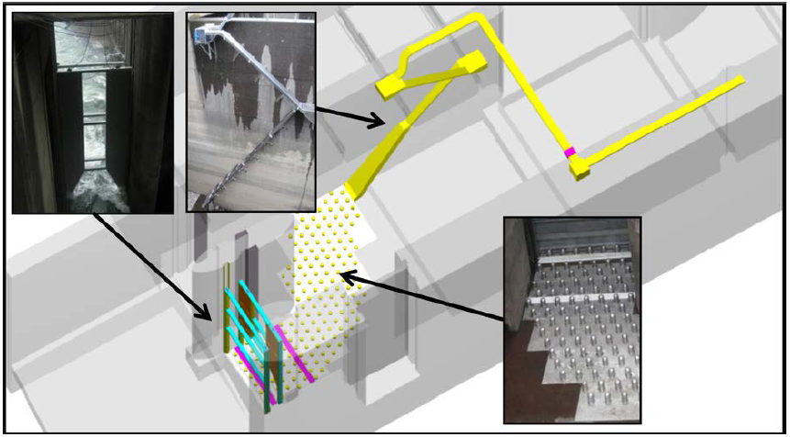
Cascades Island entrance improvements (2009)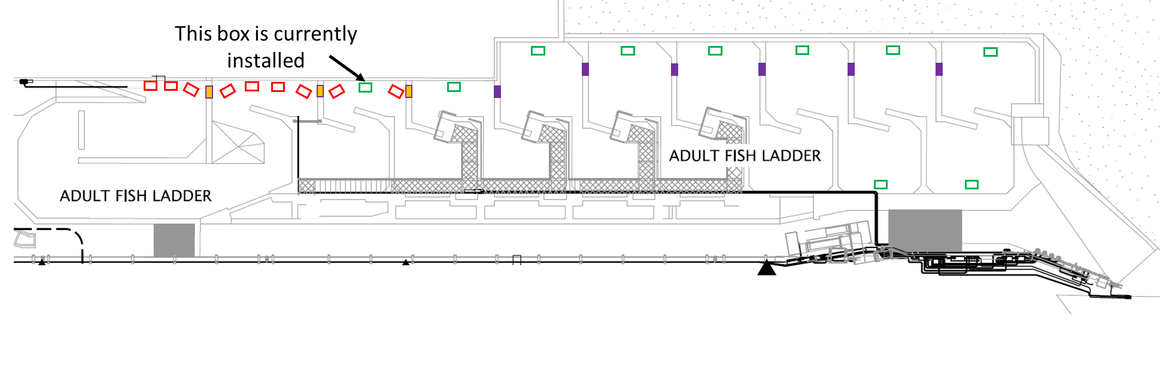

Fish Facility Design Review Work Group (FFDRWG)

USACE, Portland District

Project Update
Date Prepared/Updated: 2021-08-03

BON2 adult lamprey passage improvements
Project Identifier: | P2 # 492401
Project Manager (PM): | Bob Winters (CENWP-PM-FP)  Robert.Winters@usace.army.mil
Technical Lead (TL): | Shari Dunlop (CENWP-ENC)  Shari.L.Dunlop@usace.army.mil
FFDRWG Coordination (FC): | Jacob Macdonald (CENWP-PME)  Jacob.Macdonald@usace.army.mil

Project Description
Full redesign of control section (DDR, P&S, Construction).
2020 CRS BA Chapter 2: Proposed Action (pg.2-85): “This measure would modify the serpentine-style flow control sections of Bonneville Dam’s Washington Shore and Bradford Island fish ladders, converting them to Ice Harbor-style vertical slot with submerged orifices configurations. This would improve passage conditions for adult lamprey and likely reduce stress and delay for adult salmon, steelhead, and bull trout. All full-duplex passive integrated transponder (PIT) arrays currently located in the control sections of these ladders would be replaced in kind or improved to maintain or enhance current levels of detection of PIT-tagged anadromous fish.

Project Schedule
Design: FY2021-FY2024
Construction: Winter 2024/2025
Evaluation/Follow-on: FY2025-FY2026
Closeout: FY 2027
Preliminary Milestones:
- Project Kick-Off: ~ August 2021 (FY21 Q4)
- 30% DDR: ~ December 2021 (FY22 Q1) *FFDRWG review ~Jan 2022
- 60% DDR: ~ April 2022 (FY22 Q3) *FFDRWG review ~May 2022
- 90% DDR: ~ July 2022 (FY22 Q4) *FFDRWG review ~Aug 2022
- Draft-Final: ~ September 2022 (FY23 Q1) *FFDRWG review ~Oct 2022
- [Start P&S after 90% DDR DQC is complete, ~August 2022]

Current Status
Ongoing preliminary hydraulic work leading to a site-specific cost estimate ~October 2021.

Topics for FFDRWG Review/Coordination
None currently.
